SECTION A (40 MARKS)
- Which African island country is crossed by the Equator?
……………………………………………..…..……………………………………………
- Give any one reason why the government makes by-laws.
……………………………………….……..………………………………………………
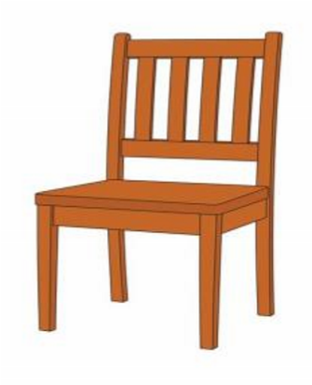
- Name the representation of a chair drawn below.

…………………………………………………………………….
- Give one reason why land is regarded as the most important resource.
……………………………………………………….……………………………………..
- What is meant by the term Population Structure?
……………………………………………………………..…………………………………
- What name was given to the military force of Chief Mirambo?
…………………………………………………………………..……………………………
- How are mangrove forests important to the ship building industry?
…………………………………………………………..……………………………………
- State any one difference between customs duty and excise duty as sources of government revenue.
…………………………………………………………………………………………………
- Name any one personality who was involved in the formation of the
East African Community in 1967.
……………………………………………………………………………….……………...
- The influence of tik-tok has grown in Uganda over the years. State any
one importance of tik-tok to traders.
……………………………………………………………………………………..……………

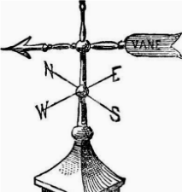
Study the diagram below and answer the questions (11-12).

- Name the weather instrument shown above.
………………………………………………………………..……………………………
- The pointer of the instrument above was pointing towards the east, to which direction is the wind blowing?
…………………………………………………………………………………………………
- State any one way the CAO is similar to the permanent secretary in
terms of their roles.
………………………………………………………….……………………………………
- Mention any one-way Missionaries contributed to the social wellbeing of people in East Africa.
…………………………………………..……………..………………..……………………
- Give any one importance of a national identity card to a citizen.
………………………………………………………………...……………………..………
- What was trans-Atlantic trade?
…………………………………………………………………..………………..…………
- In which way did the Legislative Council help Africans during independence struggle in East Africa?
……………………………………………………..……………...…………………………
- State any one reason why Antarctica continent is not suitable for human settlement.
……………………………………………………..………………...…………………………
- What method is used to get political leaders in Uganda?
……………………………………………………..………………...…………………………
- Why does the government discourage the use of undersized nets for fishing?
…………………………………………………………………..…..………………………..
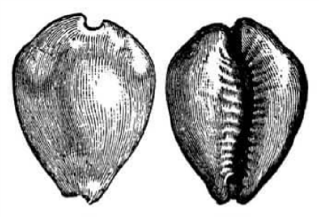
- What name was given to the form of currency illustrated below?

…..…………………………………………………..…..………………………………………
- How did the construction of the Uganda railway help to stop slave trade?
…………………………………………..…..………………………………………………….
- Name any one month in a year when equinox takes place.
……………………………………………………..…..……………….………………………
- In which way is meteorological information useful to crop farmers?
…………………………………………………………………………….…………………….
- Give any one reason why the Uganda railway was extended to Kasese District in Western Uganda.
……………………………………………………………………..…………………………..
- What title is given to the head of the Executive organ of government?
………………………………………………………………………………..…………………
- State any one reason why the Uganda Women’s Effort to save orphans was formed.
………………………….………………………………………………………………………
- Name the vegetation zone found along the coastal plain of Kenya.
…………………………………………………………………………………………………
- Why does Uganda use English as her official language?
…………………………………………………………………………….……………………
- State any one way of reducing the cost of electricity at home.
………………………………………………………………………….………………………
- Which physical feature covers the largest portion of East Africa?
…………………………………………………………………..………………………………
- Name the country that Uganda is east of.
………………………………………………………………….………………………………
- Mention any one disadvantage of using traditional means of communication.
…………………………………………………………………………………………………...
- Which evidence is there to show that Lake Victoria is on a higher altitude than Lake George?
…………………………………………………..………………………………………………
- Why is it shorter to travel by aero plane from Entebbe to Kitgum?
…………………………………………………………………………………… ...
For each of the questions 36 to 40, answer EITHER the Christian OR Islamic question but NOT BOTH. No marks will be awarded to a candidate who attempts both alternatives in a particular number.
- EITHER: Name any one of God’s promises to righteous Christians. ……………………………………………..….………………………………………….
OR: Name any one of Allah’s promises to righteous Muslims.
………………………………………………………..…………………………………
- EITHER: Which punishment was given to Adam by God for his disobedience?
……………………………………………………………….………………………………
OR: Which punishment was given to Adam by Allah for his disobedience?
…………………………………………………………………………………………………
- EITHER: Identify any one item Christians pay as offertory in the church.
……………………………………………………..………………....…………………………
OR: identify any one item Moslems pay as Zakat.
………………………………………………..…………..…...…………………………
- EITHER: Write UJCC in full.
OR: Write UMSC in full.
…………………………………..……………………………..…..……………….…………
- EITHER: Mention any one way Christian religious organizations promote development in Uganda.
………………………………………………………………........................…………………
OR: Mention any one way Islamic has contributed to development.
………………………………………..………………………………………………………...
SECTION B: 60 MARKS
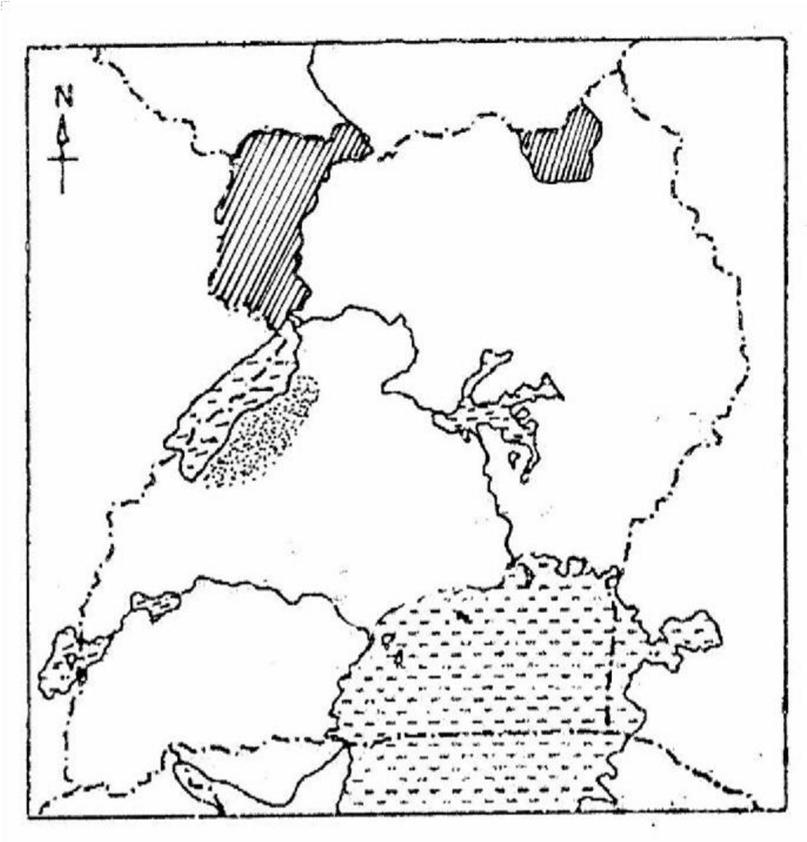


- Study the map below and answer the questions that follow.

W

V

X

z

          - Name the kingdom found in area marked V.
……………………………………………………………….…..………………………
          - Which tourist attraction is famous in the game park marked W?
………………………………………………………………...…..………………………
          - Why is area marked X favourable for tobacco growing?
…………………………………………………………....…..…………………………..
          - How does lake marked Z promote trade in Uganda?
…………………………………………………….………..…..…………………………..
42 ) What is a common market?
……………………………..…………………..…………………..……………………..

b) Mention any two common markets in which Uganda is a member.
          - ……………………………………………………………………..…………
          - ………………………………………………………………………..………
c) Give one reason why countries form common markets.
……………………………………………………………………………………..
43. Match the elements of a map in list A to their function in list B
Element of a map | Function
Compass direction | Tells what a map is all about
Key | Used to show direction of places on a map
Scale | Used to interpret map symbols
Title | Used to calculate actual ground distance between places on a map

          - Compass direction: ……………………………………………..……..…..
          - Key: ………………………………………………………………………….
          - Scale: …………………………………………………………………….....
          - Title: …………………………………………………………………………
44.a) Name the first group of European Explorers to come to East Africa.
i) ……………………………………………………..………………………….
ii) ………………………………………………….…………………….……….
        - State the main reason why the above group wanted to find out the sea route to India.
………………………..………………………………………………………………….
Which evidence is there to show that the above group once lived in East
Africa.
……………………………………………………..……………………………………
c) Give one effect of the coming of the above group to East Africa.
…………………………………………….……………………………………………..
45. A) Mention any two importance of wildlife in Uganda’s game parks.
              - …………………………………………….…………………………………………..
              - ……………………………………………..…………………………………………..
(b) State any one way tourism can be a threat to a country.
……………………………………….………………………………………………..
c) Give one reason why tourism is called an invisible export.
……………………………………………………………………………………………
46. a) State any one way the Bachwezi contributed towards the growth of the following sectors in Uganda.
i) Agriculture ……………..…………………………………………………………………
ii) Mining ………………….………………………………………………………..………
iii) Games and sports ………………………………………………………..………….
b) Which factor led to the final collapse of the Chwezi Empire.
…………………………………..………………………………………………………...
47. (a) Define the following terms as related to rivers.
i) Delta ……………………….………………….……………………………………
………………………………………………………………………………..
ii) Estuary ………………………………………………………………………………
……………………………………………………………………………….
iii) Tributary……………………….………………….…………………………………..
………………………………………………………………………………..
(b) State any one political importance of rivers.
………………………………………………………………………………….………
48.a) State any two roles played by judiciary organ.
i) …………………………..………………………………………………………
ii) ………………………..…………………………………………..……………
b) What title is given the head of the Judiciary organ of government?
………………………………………………………...……………………………….
c) Apart from the Judiciary, give any one other organ of a democratic government?
……………………………………………………………..…………………………...
49. (a) Give any two reasons why the Banyoro staged the Nyangire rebellion.
              - ………………………………………………………………………..………
              - ……………………………………………………………………………......
b) Mention any two positive effects of the Mau Mau rebellion in Kenya.
          - …………………………………………………………………………………
          - …………………………………………………………………………………
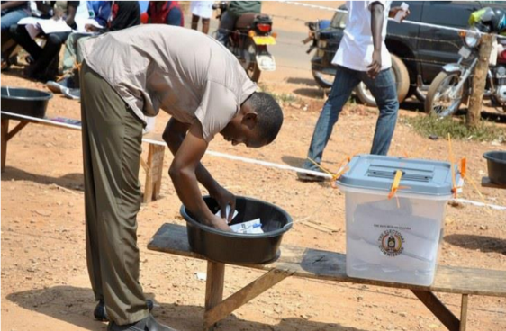
50.a) Which system of election is illustrated below.

…………………………………………………………….…………………………
        - State any two advantages of the above system of elections
…………………………………….……………………………………………………...
        - What name is given to an election that is held to fill a vacant political post.
………………………………………………….………………………….………………….
For each of the questions 51 to 55, answer EITHER the Christian OR Islamic question but NOT BOTH. No marks will be awarded to a candidate who attempts both alternatives in a particular number.
51.EITHER: (a) Why did God destroy human race by floods during the time of Noah?
……………………………………………..…………………………………………………
            - How was Mount Ararat useful to Noah at the end of floods?
………………………………………..…………………………….……………………
            - Which bird took an olive branch to Noah after the floods?
…………….……………..………………………………………………………………
            - What did God use as a symbol of His covenant that God made with Noah?
……………………….……………………………………………………………………
OR: (a) Why did Allah destroy human race by floods during the time of Prophet Nuhu?
………………………………..………………………………………………………………
            - How was Mount Arafat useful to Nuhu at the end of floods?
……………………………………………………………………….……………………
            - Which bird took an olive branch to Noah after the floods?
…………….………….……………………………………………………………………
            - What did God use as a symbol of His covenant that God made with Noah?
………………………...……………………………………………………………………...
52. EITHER: (a) Name any one type of suffering.
………………………………………………………………………………………………
(b) Mention any two causes of suffering among Christians.
        - …………………...…………………………………………………………
        - ……………………………………………………………...………………
(c) What should a Christian do in times of suffering?
…………………………………………………………………………………………………
OR: (a) Name any one type of suffering.
……………………………………………..………………………………………………
(b) Mention any two causes of suffering among Muslims.
        - ………………………………………………………………………………
        - ………………………………………………………………………………
(c) What should a Muslim do in times of suffering? …………………………………….………………………………………………………
53. EITHER: (a) May the grace of our Lord Jesus Christ and the love of God and the fellowship of the Holy Spirit be with us all, now and forever more Amen.
……………………………………...……………………………..…………………..……
(b) Mention any two requests made in the above prayer.
      - …….……………………………...…………………..……………………..…………
      - ………………………………………………………………………………………….
(c) State any one importance of prayer to Christians.
……………………………………………………….…………………………………..
OR: (a) Mention any two types of prayer in Islam.
……………………………………………………………….……………………………
(b) Give any two importances of prayer to Moslems.
          - …………………………………………..………………………………...........
          - ……………………………………………………………………………..……
54. EITHER: (a) Mention any two ways the devil tempted Jesus while He was in the desert.
i)…………….…………………………………………………………………………
ii)………………………………………………………………………………………
          - What helped Jesus to overcome the temptations of the devil?
………………………………….……………………………………………………………
          - Mention any one religious practice that can help Christian to overcome devil’s temptations.
………………………..……………………………………………………………………
OR: (a) Give two reasons why Prophet Muhammad performed the Hegira.
          - ………………………………………………………………..………………
          - …………………………………………………………………..……………
          - Name any one place visited by Muslims while during Hijjah in Mecca
……………………………………………………………………………………………
          - Mention one condition to be fulfilled by a Muslim before performing
Hijjah.
………………………………………….……………………………………………………
55. EITHER: (a) Name any two law books in the Bible.
i)………………………...……………………………….…………………………….
ii)…………………………...……………..………….………………………………….
    - State any one importance of a Bible in a Christian family.
……………………………………………………….……………………………………
    - Give any one way of showing respect to the Bible as a Holy Book.
………………………………………………….……………………………………...
OR: (a) Name any two other Holy books in Islam besides the Qur’an.
        - ……………………………………………………………………………………
        - ……………………………………………………………………………………
    - State any one reason why Muslims recite a Qur’an.
……………………………………………..……………………………………………
    - Give one way of showing respect to the Qur’an as a Holy Book.
……………………………………………………….…………………………………………

